
MN50753 Simulation Coursework 2023-24
by Ritwik Singh

MSc Business Analytics
School of management
University of Bath


Word Count: 2041

School of Management

Coursework Submission Sheet

Student name(s) | % |  | %
Ritwik Singh | 100
For group work – individual % contributions need to be stated only where they are not equal.
Department (e.g. Management): Management
Programme and Year of Study: MSc Business Analytics 2023-24
Name of lecturer: Zehra Önen Dumlu
- Unit title and code: Heuristics and Simulation MN50753
- Number of pages in assignment: 14 Word count: 2041

Declaration

I/we certify that I/we have read and understood the entry in the relevant Student Handbook for the School of Management on Cheating and Plagiarism and that all material in this assignment is my/our own work, except where I/we have indicated with appropriate references. I/we agree that, in line with Regulation 15.3(e), if requested I/we will submit an electronic copy of this work for submission to a Plagiarism Detection Service for quality assurance purposes. I/we also confirm that the percentage allocation of work is as shown above.

Upload your coursework via the Unit’s Moodle Page by the specified submission date and time. For Moodle submissions, this form should be available on Moodle site for the relevant unit and can be pasted into the front page of your assignment if requested by your tutor. Copies are also available from Management Reception.

You should aim to hand your work in before the deadline given by your lecturer/ tutor. The University guidelines on penalties for late submission are as follows:

Any assessment submitted late without an agreed extension, will receive a maximum mark of 40%. Any assessment submitted more than 5 working days without an agreed extension will receive a mark of zero

For all Moodle Submissions, your marks and feedback should be returned to you via Moodle.

All work is internally moderated. For all work that contributes towards a final degree classification, a sample of work with supporting documentation for each unit is sent to an External Examiner for review and comment.

Please note that any mark given is provisional and is subject to confirmation by the relevant Boards of Examiners for Units, Programmes and Boards of Studies. These normally take place at the end of each Semester.

Contents
1. Project Aim 5
2. Understanding the Process 5
2.1 Customer Arrivals 5
2.2 Server Types 5
2.3 Server Breaks 5
2.4 Feedback Analysis 5
3. Building the Model 6
4. Result Analysis 7
5. Assumptions and Limitations 12
6. Conclusion 13
7. Appendix 14

Project Aim
The aim of this coursework is to utilize Arena simulation software to model and analyse the operations of a small-scale call centre. By simulating the call centre environment, we aim to evaluate various performance metrics and identify areas for potential improvement. This report provides a detailed analysis of the simulation results, offering insights into the efficiency and effectiveness of call centre operations.

Understanding the Process

Customer Arrivals
Premium customers have a higher priority and are served by either experienced or rookie servers. Specifically, 40% of premium customers are directed to experienced servers upon arrival, while the remaining 60% are served by rookie servers. All standard customers are directed to rookie servers.

Server Types
Upon arrival, premium customers spend Triangular(5,7,10) minutes on average waiting to be served, while standard customers spend EXPO(3) minutes on average. Premium customers have a waiting tolerance with a normal distribution (mean: 5 minutes, standard deviation: 1 minute), while standard customers have a waiting tolerance with a normal distribution (mean: 8 minutes, standard deviation: 2 minutes).

Server Breaks
There are 2 experienced and 3 rookie servers working in the call centre. One experienced server takes a lunch break between 12:00-13:00, while the other takes a break between 13:00-14:00. Rookie servers take lunch breaks individually in sequential time slots: 12:30-13:30, 13:30-14:30, and 14:30-15:30.

Feedback Analysis
After the call ends, customers are asked to complete a brief feedback questionnaire. Two individuals, Alan, and Mary are responsible for analysing these feedback forms. They wait until 15 feedback surveys are collected before analysing them and is measure with Input Analyser using the values as given in Table I (see appendix).
These operational processes and policies govern the functioning of the call centre, which will be simulated using Arena software to evaluate performance metrics and identify areas for improvement.

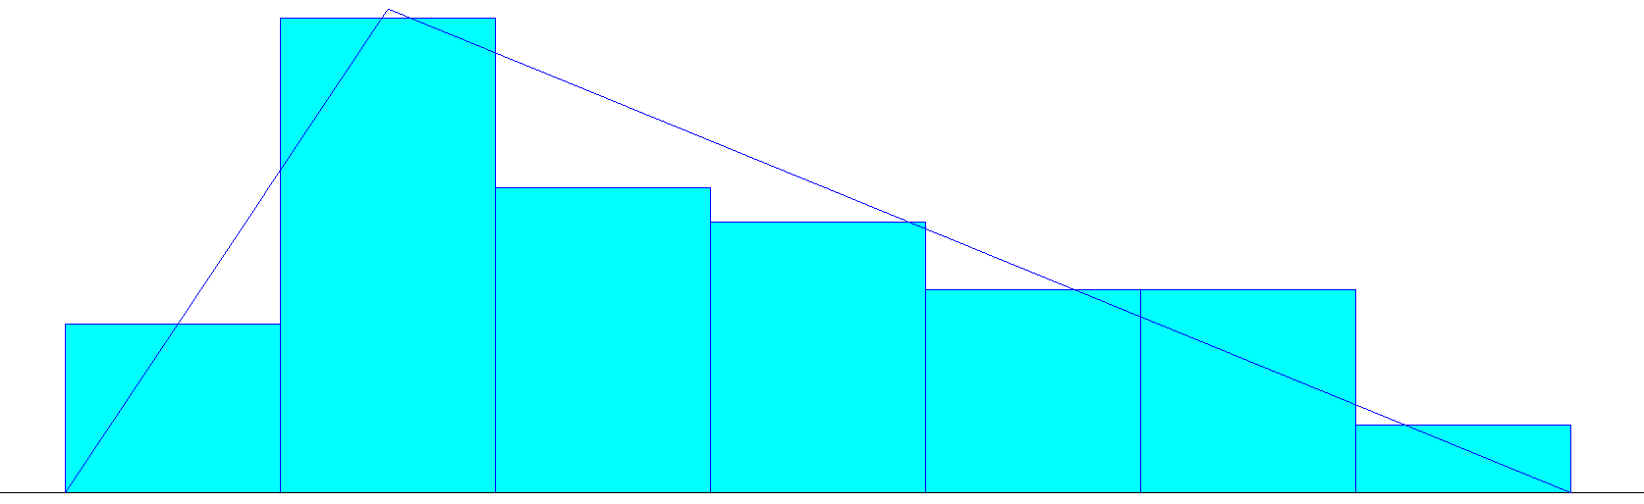
Fig 1: Feedback Analysis Distribution Summary
The feedback analysis revealed that customer responses align with a Triangular distribution, centred around a mean score of 7.08. Statistical tests, including Chi Square and Kolmogorov-Smirnov, confirm a good fit between observed and expected distributions, indicating the reliability of the model. With 50 data points ranging from 5.46 to 9.46, the analysis provides valuable insights into customer sentiment, helping in decision-making for customer satisfaction.

Building the Model
Considering all the aspects under which the call centre works, an Arena model is developed which tell more about the present working of the call centre. The model is run for 8 hours from 9AM to 5PM for 40 replications.
The working Arena model of the call centre is shown below:
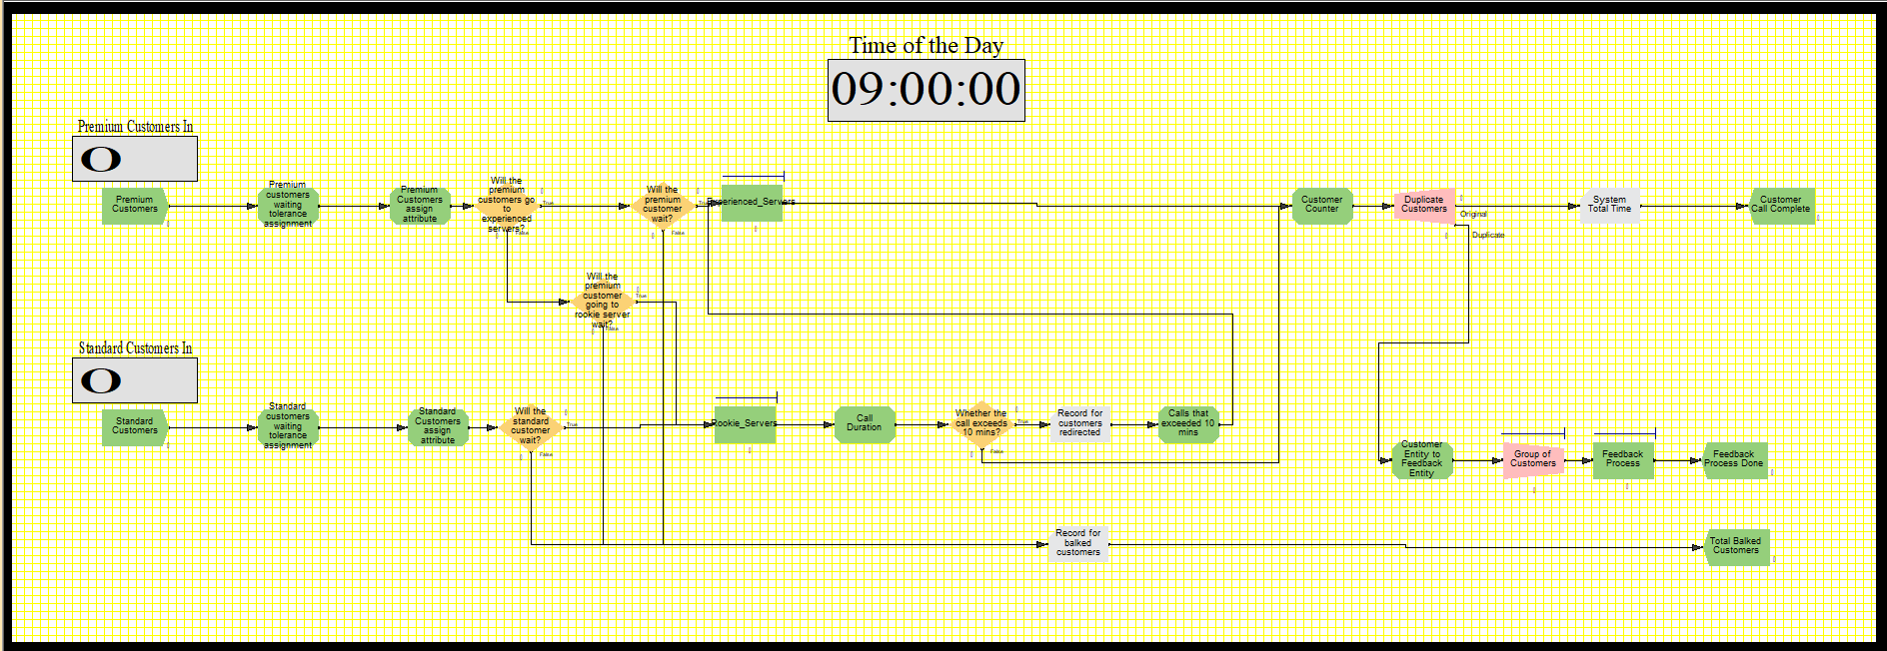Fig 2: Initial Arena Model

Result Analysis
- Statistical and Performance Analysis
After building the model as shown in Fig 2, several parameters were calculated for the analysis as follows:
Table 1: Analysis of Analysis Parameters of Initial Arena Model
The simulation analysis results reveal several key performance indicators, as follows:
- Average Waiting Times: The rookie server queue shows an impressively low average waiting time of ~0.021 minutes, displaying efficient handling of incoming calls. In contrast, no waiting time is observed in the experienced server queue, indicating quick resolution of escalated issues by experienced servers.
- Utilization Rates: Rookie servers operate at an average utilization rate of ~31.42%, indicating potential capacity for additional load or optimization. However, experienced servers demonstrate a lower utilization rate, averaging around 11.50%, showing the possibility of underutilization of resources in this part.
- Customer Priority: Premium customers are given priority in the service queue, experience significantly shorter waiting times compared to standard customers, with averages of ~0.008 minutes and 0.024 minutes, respectively.
- Overall System Efficiency: The average time spent in the system by a customer, irrespective of customer type, is ~4.90 minutes, reflecting the system's efficiency in resolving inquiries on time.
- Escalated Calls: An average of 4.35 calls are directed from rookie servers to experienced servers, indicating the frequency of escalated issues requiring the expertise of experienced servers.
- Customer Satisfaction: The low number of customers that abandon their calls due to excessive waiting, averaging at 0.025, suggests that the call centre maintains satisfactory service levels, minimizing instances of customer dissatisfaction.
- Feedback Analysis: Alan and Mary operate at an average utilization rate of ~5.42%, indicating sufficient capacity to provide valuable insights to management for continuous improvement of the system.

- Recommendations for System Improvement
- Queue Threshold Alerts: Introduce queue threshold alerts to notify management or the supervisors when queue lengths exceed predefined thresholds. This enables intervention to allocate additional resources, adjust the staffing levels, and implement queue management strategies to prevent service disruptions and minimize waiting times.
- Modified Customer Segmentation: It is recommended to implement a customer segmentation strategy based on past call data within the call centre operations. By analysing metrics such as average call time, feedback scores, types of services requested, and other relevant parameters, customers can be effectively categorized into distinct groups like standard or premium. This segmentation enables the delivery of personalized service, with premium customers receiving prioritized support and tailored solutions based on their historical interaction patterns. Moreover, leveraging past call data facilitates the identification of trends and preferences among different customer segments, empowering the call centre to make proactive service adjustments and targeted improvements to enhance overall customer satisfaction and operational efficiency. Integrating historical call data analysis into the workflow allows agents to deliver more personalized and effective service, ultimately contributing to higher customer loyalty and retention.
- Introduction of a New ‘Expert Server’: To further enhance the call centre's operational efficiency and address prolonged call resolution times, it is recommended to introduce a new server dedicated to handling unresolved inquiries that exceed a specified time limit, typically beyond 15 minutes even after consultation with experienced servers. This additional server, termed as the "Expert Server," would be responsible for managing escalated issues and providing specialized support to customers requiring extended assistance. By introducing this specialized role, the call centre can mitigate the risk of prolonged waiting times and improve overall customer satisfaction by ensuring that complex queries receive the attention and expertise they require without causing delays for other callers. Additionally, the Expert Server can contribute to workload balancing strategies, allowing experienced servers to focus on resolving routine inquiries efficiently while addressing more intricate issues separately.
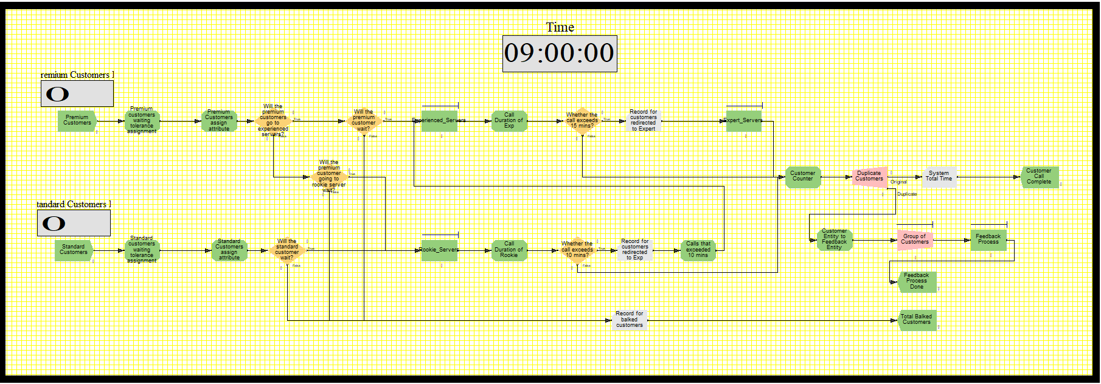
Fig 3: Recommended Arena Model
This recommendation aligns with the call centre's objective of optimizing service quality and responsiveness, ultimately enhancing the customer experience and organizational performance.
Table 2: Comparison of Parameters between Initial and Recommended Models
In comparing the performance metrics as shown in Table 2, between the initial model ‘Values (a)’ and the model with the addition of an expert server ‘Values (b)’, several notable improvements are observed. Firstly, the average waiting time for premium customers decreased from 0.008 to 0.007 minutes, reflecting a prompter response to high-priority calls. The overall utilization rate experienced servers remained consistent at 11.50%, suggesting a balanced workload distribution despite the introduction of the expert server. However, the utilization rate of rookie servers decreased from 31.40% to 30%. These improvements collectively suggest that the addition of the expert server has led to a more optimized system with reduced waiting times and improved handling of complex queries, ultimately enhancing overall customer satisfaction and operational efficiency.

- Impact of Premium Customer Handling Change

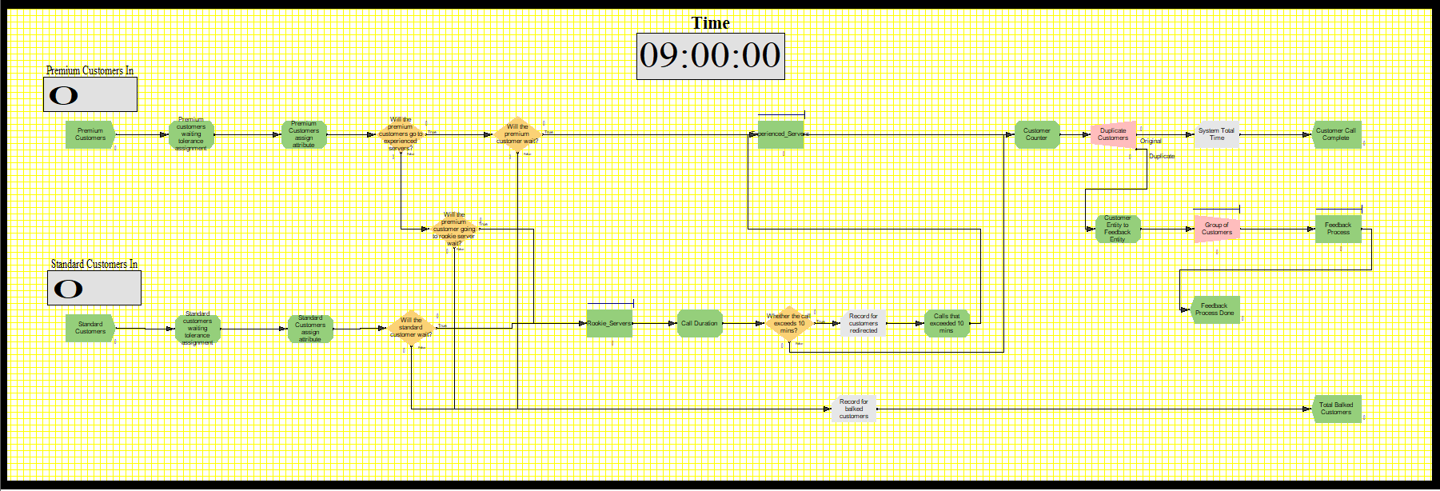
Fig 4: Modified Arena Model
In the below table, ‘Values (a)’ represents the values from the above Statistical and Performance Analysis, and ‘Values (c)’ represents the values calculated after making changes to the initial Arena model as shown in Fig 2.
Table 3: Comparison of Result Parameters of Modified Arena Model
- Reduced Waiting Times: The average waiting time in the rookie server queue increased from 0.021 minutes to 0.025 minutes, while the waiting time for premium customers increased from 0.008 to 0.013 minutes. However, this change is due to the increased utilization of the rookie servers, indicating that more customers are being served overall.
- Improved Server Utilization: The utilization of rookie servers increased significantly from 31.40% to 42.54%, indicating that they are handling more calls efficiently. The utilization of experienced servers decreased significantly from 11.50% to 0.43%. This suggests that the workload distribution among servers has become less balanced, leading to decreased efficiency or underutilization of experienced servers.
- Impact on Customer Satisfaction: Although the waiting times for standard customers increased slightly from 0.024 to 0.034 minutes, the overall time spent in the system by a customer remained relatively stable at around 4.9 minutes. This indicates that despite the increase in waiting times, customers are spending a similar amount of time in the system, which may not significantly impact their satisfaction.
- Effectiveness of Premium Customer Handling: The number of calls directed to experienced servers from rookie servers increased from 4.35 to 6.15, suggesting that the new method of directing premium customers based on queue length is effectively balancing the workload between the two types of servers.
- Consistency in Customer Behaviour: The number of premium/standard customers that balk remained constant at 0.025, showing that the change in the model did not significantly impact customer behaviour or dissatisfaction.

The 95% confidence interval tells that in multiple simulations, it is probable that the actual population parameter will fall within this interval approximately 95% of the time. For example, for the average utilization of Alan and Mary, which is 0.054, its 95% confidence interval is (0.051343367, 0.057391904). This suggests that there is a 95% confidence level that the genuine average waiting time lies between these specified values. This principle also applies to other parameters, such as the average waiting time of premium customers, providing a range within which the true values are expected to exist with 95% confidence.
In conclusion, while the changes implemented in the model have led to improved server utilization and more balanced call handling, further analysis and modifications in configuration is necessary to optimize waiting times and ensure optimal customer satisfaction.

Assumptions and Limitations
- Assumptions:
- The customers are asked to fill out the feedback questionnaire, and the analysis is started only after reaching a threshold of 15 feedback. This may not accurately simulate real-world scenarios where customer engagement with feedback mechanisms can vary.
- The simulation assumes that customer waiting tolerance has a normal distribution with specified means and deviations. This simplification does not fully capture the complex behaviours of customers who react differently based on past experiences or expectations.
- It is assumed that experienced and rookie servers have consistent skill levels throughout the simulation. Individual performance may vary due to factors like fatigue, learning over time, or personal problems.

- Limitations:
- The current model lacks mechanisms to adapt server allocation or break schedules based on live data, disturbing its ability to respond dynamically to changing conditions.
- Service times are uniformly applied based on customer type and server experience, not considering the potential variations within these groups. Service times can vary significantly due to the complexity of individual queries or differences in server efficiency.
- The assumption that all customers provide feedback, analysed in batch mode, may not reflect how continuous feedback can be leveraged for real-time service improvements. Implementing a more realistic feedback mechanism that enables continuous analysis could facilitate timely adjustments and enhance service quality.

Conclusion
In examining the detailed dynamics of a small-scale call centre through Arena simulation software, this coursework put light on the operational complexities and revealed opportunities for improvement. By delving into the minute details of customer arrivals, server types, breaks, and feedback analysis, a comprehensive understanding of the call centre ecosystem emerged, laying the base for informed analysis and recommendations. The simulation results, encapsulated in statistical and performance analyses, showing key performance indicators, showcasing both the commendable efficiency and the areas of improvement within the call centre operations. From reduced waiting times for premium customers to the proper allocation of resources and the introduction of novel strategies like queue threshold alerts and customer segmentation, the report makes a way for operational excellence and improved customer satisfaction. Further, the proper examination of assumptions and limitations underlined the complexities in the modelling of real-world scenarios and emphasized the use for continued refinement and adaptation. As the call centre navigates the dynamic landscape of customer service, the insights taken from this analysis serve as a light guiding its evolution, helping in the betterment of both efficiency and customer-centricity of the system.

Appendix

6.161 | 7.746 | 6.27 | 5.918 | 7.186
8.891 | 6.727 | 6.298 | 5.562 | 8.178
8.138 | 7.007 | 8.318 | 6.029 | 5.537
5.891 | 7.073 | 7.165 | 8.903 | 5.462
6.264 | 7.6 | 7.832 | 6.92 | 8.161
6.215 | 6.64 | 5.759 | 6.174 | 6.717
6.636 | 7.422 | 5.926 | 8.68 | 6.174
9.117 | 5.884 | 5.686 | 8.497 | 5.586
8.722 | 9.457 | 7.57 | 6.923 | 7.469
9.203 | 7.38 | 6.81 | 8.027 | 6.096
Table I

